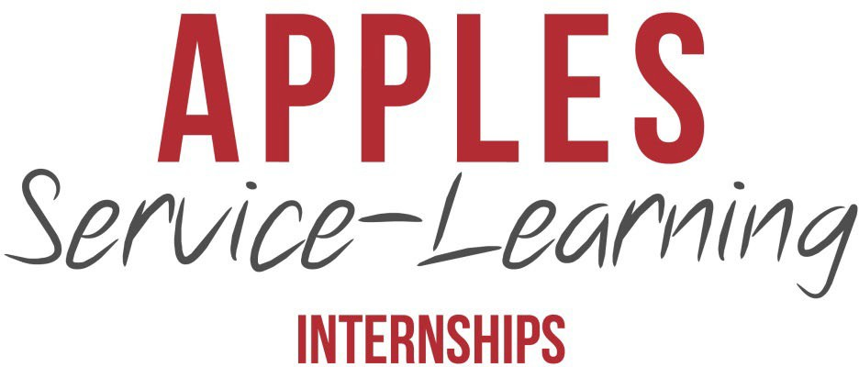

SUMMER 2023

A Letter from the Internships co-chairs

Greetings,

On behalf of the APPLES Service-Learning program and the Carolina Center for Public Service, we extend our deepest gratitude to you for your shared interest in public service and commitment to community engagement, especially amidst this pandemic.

This packet details all of the available APPLES internship positions for Summer 2023.

All of the internship opportunities are designed for students to gain professional experience. APPLES interns agree to complete up to 320 hours of work, receive a $4,000 stipend, and enroll in a one-credit hour service-learning course in the Spring semester through UNC’s School of Social Work and Carolina Courses Online.

As former interns, we can personally attest to the power of the APPLES internship program. Through sustained partnerships, APPLES and its community organizations provide mutually beneficial relationships that enhance both student learning and community partner success. While students receive a stipend and course credit, their contributions assist with projects that uphold the mission and values of the community partners. Together, this dynamic relationship creates a unique and impactful internship experience.

Information about each internship site and the respective position description is detailed in this packet. Should you have additional questions, be sure to reference the APPLES website or contact APPLES.

Applications are due Friday, April 14, 2023.

Thank you for your interest in APPLES Service-Learning Internships and your commitment to public service and the community. We wish you the best of luck. Stay well.

Sincerely,

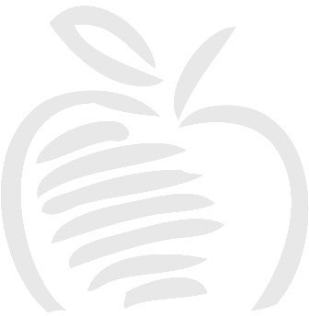
Riley Harper ’25 (riley.harper@unc.edu) Sydney Murray ’24 (sydneygm@ad.unc.edu)

APPLES Internship Co-Chairs

ccps.unc.edu/apples/service-learning-internships

Available Internships

Organization | Position
The Triangle Nonprofit & Volunteer Leadership  Center | Summer Student Leadership Coordinator
Marbles Kids Museum | Summer Camp Intern
DPS Hub Farm | Sustainable Agriculture & Education Assistant
North Carolina Botanical Gardens | Summer Intern

Intern positions: Summer Student Leadership Coordinator (1)

Transportation needed: Car needed

Website: https://thevolunteercenter.org/

Organization description: Celebrating 50 years of service to the community, The Triangle Nonprofit and Volunteer Leadership Center (TNVLC) is a 501(c)(3) charitable nonprofit organization. TNVLC began operations in February of 1972 as a way to help fill the unmet needs in our community.

The Triangle Nonprofit & Volunteer Leadership Center strengthens nonprofits and engages volunteers to create a more vibrant community. We inspire, equip, and mobilize nonprofits and volunteers to take action that changes our community.

Internship details: The intern will serve as the coordinator for our Summer Student Leadership Programs. The programs include:

- IMPACT Camp Advisor (Leadership/Service Camp). Students visit a different nonprofit each day to learn about community needs and the mission of the organization (ex. environment/food insecurity/poverty). While at the nonprofit, students participate in hands-on service projects related to the work of that agency.

- Civic Engagement Leadership Institute (CELI) Advisor. CELI is a deep dive into understanding the root causes of community needs. Students hear from community leaders and get practical leadership skills culminating with a Capstone Project presented to community judges (think Shark Tank).

- Other Leadership Program Weeks such as Model UN
Core Responsibilities of the above include: finalize curriculum, secure service sites, schedule community speakers, program marketing, create team-building activities, lead social justice issue discussions, assign volunteers, assist students in developing Capstone projects, work with project judges, assign volunteers and serve as an Onsite Coordinator for these programs.

- Assist with Student Awards Program (if time permits).

Intern positions: Summer Camp Intern (1)

Transportation needed: Car needed

Website: https://www.marbleskidsmuseum.org/

Organization description: Located in the heart of downtown Raleigh, Marbles serves a diverse population of families, school groups and community organizations with dozens of themed exhibits, summer camps, IMAX documentary and feature movies and special events year-round.

Internship details: The summer camp intern at Marbles Kids Museum will assist museum staff with camp logistics and program delivery. Duties include assisting with before/after care, carpool, program set-up and delivery, and camp communications. As time allows, assisting with other museum programs and events. The intern will learn not only about the structure and function of Marbles Kids Museum, a nonprofit, but also the impact of play on the cognitive and social development of young children.
Major in education or communications is preferred but not required. Strong presentation/public speaking skills, a commitment to customer service, strong multi-tasking and communication skills, ability to be both a self-starter and a team player and willingness to work with preschool and elementary-age children are preferred.

Intern positions: Sustainable Agriculture & Education Assistant (1)

Transportation needed: Car needed

Website: https://www.thehubfarm.org/

Organization description: Our mission is to engage the DPS community in meaningful outdoor experiences. We do this through environmental education, community engagement events, and capacity building for outdoor learning across DPS.

The Hub Farm is a central component in a healthier school system where interdisciplinary and experiential outdoor learning supports well-being of students, staff, and the DPS community.The Hub Farm is a 30 acre outdoor learning center in Durham, NC featuring farm, forest, wetland and aquatic habitats. We grow vegetables, herbs, and flowers to share, tend a flock of chickens and ducks, and manage three honeybee hives. We follow sustainable practices in all that we do and strive to conserve habitat, enhance storm water filtration, and support native pollinators.

Internship details: The intern will assist staff in sustainable operation of the farm and property, including working in the garden and helping care for livestock. The intern will also assist staff and volunteers in facilitating environmental field trips for students aged K-12. The intern will have the opportunity to attend meetings with staff and participate in professional development activities. Finally, the intern will complete an independent project of their choice such as building a new physical element on the farm creating and implementing a lesson plan, or filming a video.

Chapel Hill, NC
Intern positions: Summer Intern (1)

Transportation needed: Car is not needed

Website: https://ncbg.unc.edu/

Organization description: The North Carolina Botanical Garden is a conservation garden. Their guiding mission is to inspire understanding, appreciation, and conservation of plants and to advance a sustainable relationship between people and nature.

Internship details: The APPLES summer intern will join the horticulture staff and other interns in caring for our garden spaces and plants, tending to plants in the nursery, and maintaining hardscape elements such as our path system. The work will be physical labor, out of doors, in a beautiful garden. This will include tasks such as weeding, watering, renovation of garden spaces, raking of paths, plant propagation, and other related activities. Over the course of the summer, interns will learn about southeastern native plants and conservation gardening and will be able to address visitor questions as their knowledge increases

